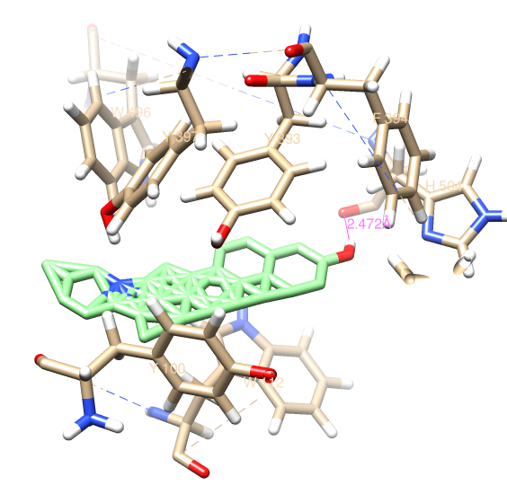

Pose1

Green coloured is ligand with disturbed structure.