Hi,

I am a user of UCSF CHIMERA. I have a problem in usage of UCSF CHIMERA. When, I open a protein structure, all of helixes and sheets are green. I very tried to change of helixes and sheets color to red and blue respectively or protein structure to be form sphere, but unfortunately I did not can. Even I study user’s guide and did to form: Tools> Depiction> Color Secondary Structure. Please guide me, very thanks.

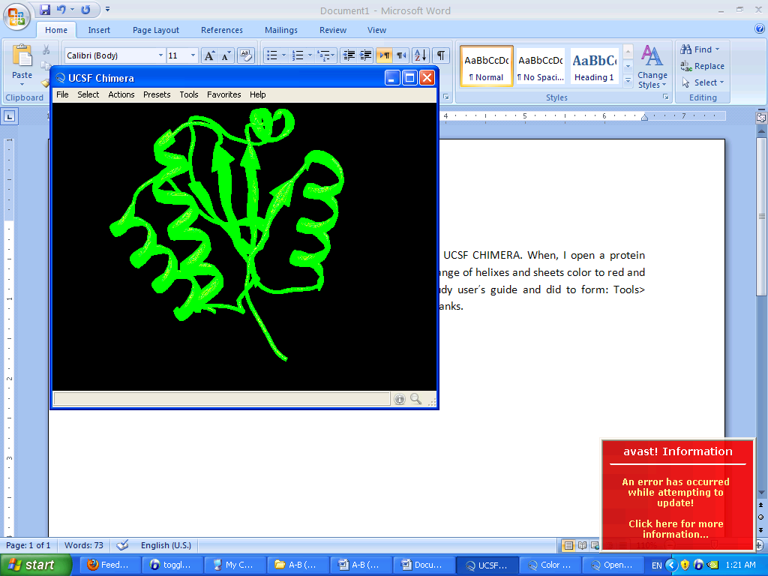My protein structure after open it.