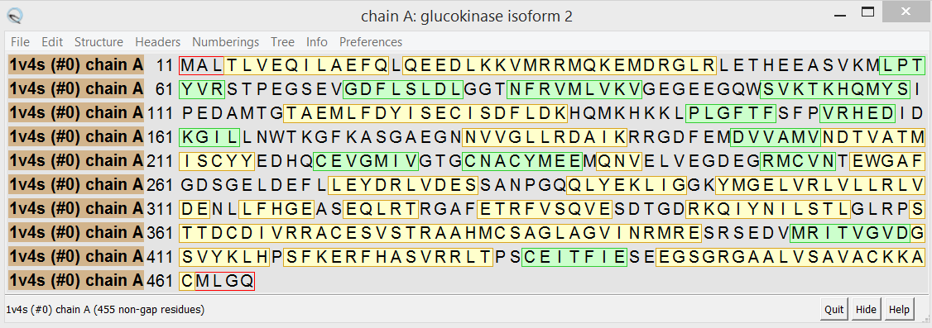
Alpha helix
Beta Sheet
Not a secondary structure and represented as simple connector, how to model this part

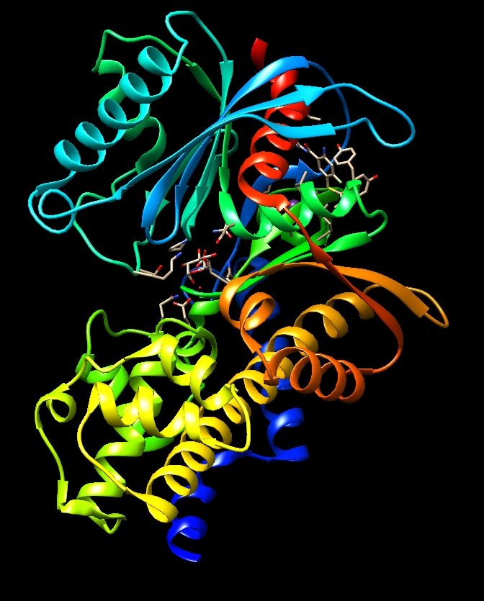
How to model these sequences that are neither alpha helix nor beta sheets?
In the build structure option, we select parallel beta sheet and anti-parallel beta sheet but how do we know that the beta sheet represented is parallel or anti-parallel do the arrow heads represent the directionality?
How to get the arrows for the directionality of beta sheets using the build structure command, I’m entering the sequence of amino acids?

