Hi,

I downloaded and installed Chimera and NLOPredict on 08 July 2017.

I used some of the functionality but Had a problem with loading a .cfg file.

I started up Chimera

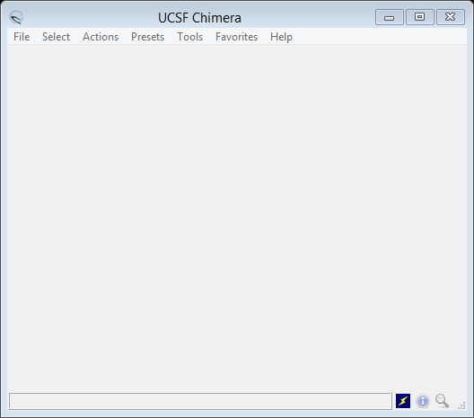

I ran the COX Inhibitors demo OK, giving

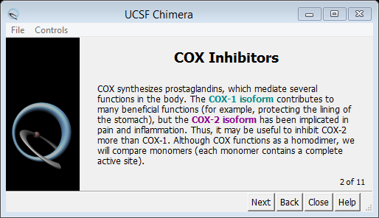

and

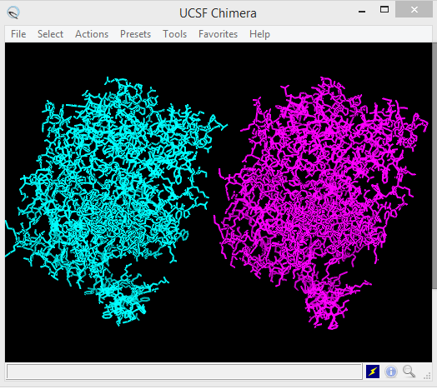

I did a search, giving

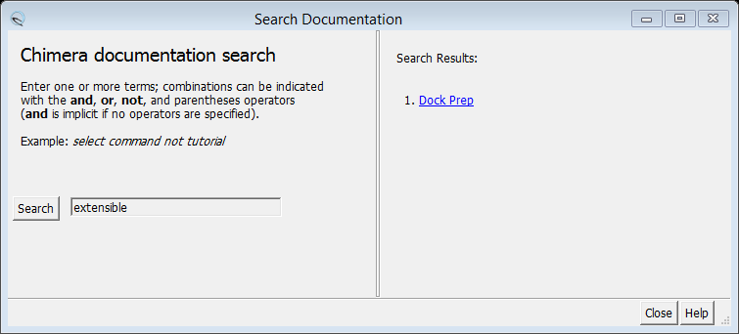

I started the NLOPredict plugin, giving

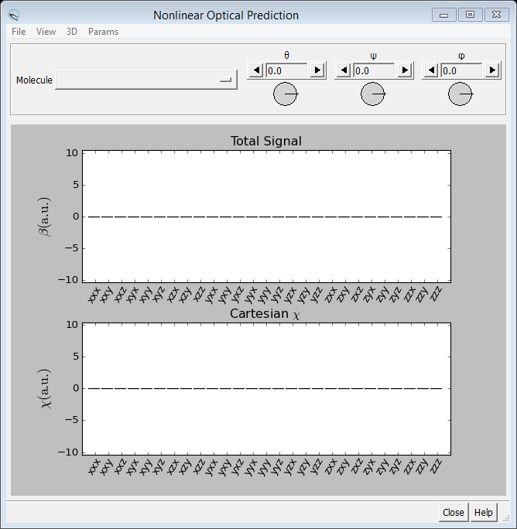

I tried to follow the directions in the NLOuse.rtf file for the use case given on the NLOPredict site

NMA.pdb seemed to load OK, giving

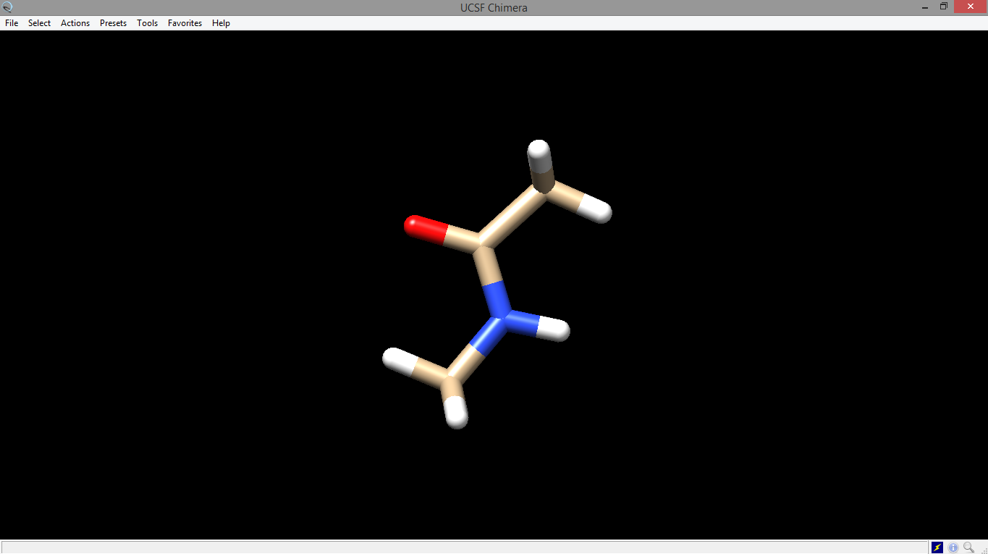

BUT, trying to load the cfg file, Amide_I.cfg led to an error

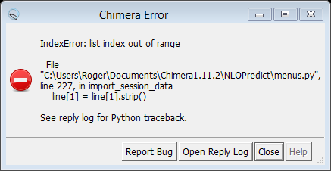

I think the file is “corrupted” ish. See Amide_I.cfg.

The reply log was probably as follows

