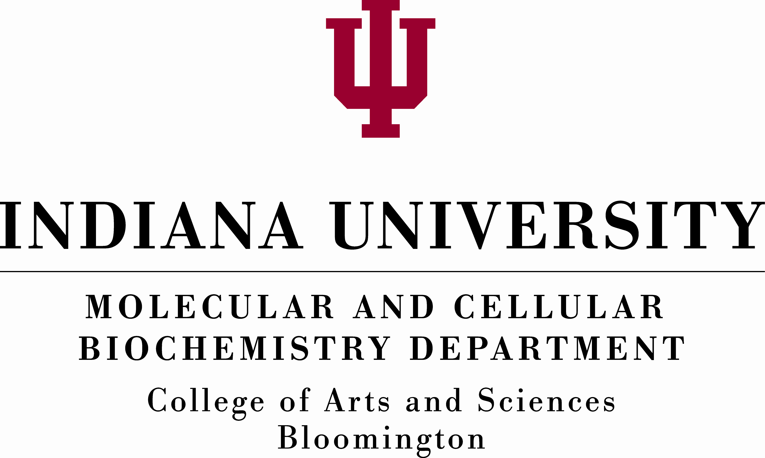

Assistant or Associate Professor
Cryo-Electron Microscopy

The Department of Molecular and Cellular Biochemistry (MCB) at Indiana University (http://www.indiana.edu/~mcbdept) invites applications for a position beginning August 2018 at the rank the Assistant or Associate Professor. The search is for candidates in all areas of biochemistry who use cryo-electron microscopy as a primary tool. Indiana University-Bloomington has immediate plans to purchase a Talos Arctica electron microscope with a Gatan K3 camera that will be part of our EM core which already includes a JEOL 3200 equipped with a DE64 direct electron detection camera. The successful candidate will be an affiliate with Indiana University’s emerging Center for Chemical Biology and Biotherapeutics (C2B2) organized under the Precision Health Initiative (PHI; https://grandchallenges.iu.edu/precision-health/index.html) in collaboration with the Indiana University School of Medicine. They will also be a trainer in our NIH funded Chemistry-Biology Interface (CBI) training program in Quantitative and Chemical Biology (http://www.chem.indiana.edu/qcb/). Successful candidates will be expected to develop or already have a visible, externally funded research program. Primary teaching assignments will involve undergraduate and graduate level biochemistry or related courses in the molecular life sciences. Interested candidates with a Ph.D. in biochemistry, chemistry or a related field with relevant postdoctoral experience should submit their application at: (https://indiana.peopleadmin.com/postings/4940). A completed application includes a curriculum vitae, a summary of future research plans. The applicant should also arrange the submission of four letters of recommendations addressed to Chair, Faculty Search Committee. Questions regarding the position or application process can be directed to: Suzanne Schwartz (mcbdept@indiana.edu). Applications received by December 15, 2017 will receive full consideration; later applicants will also be considered until the position is filled. Indiana University is an equal employment and affirmative action employer and a provider of ADA services. All qualified applicants will receive consideration for employment without regard to age, ethnicity, color, race, religion, sex, sexual orientation or identity, national origin, disability status or protected veteran status. The College of Arts and Sciences is committed to building and supporting a diverse, inclusive, and equitable community of students and scholars.

