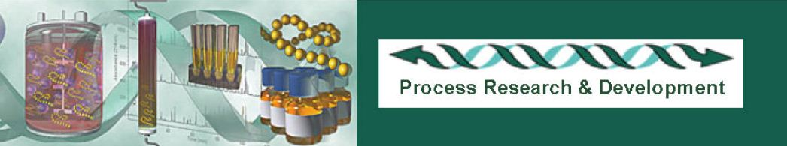

Genentech, the world’s first biopharmaceutical company, leads the industry in applying high-quality innovative science and technology to the development of important new drugs that continue to revolutionize the field of medicine.

Postdoctoral Research Fellow

This program brings together postdoctoral research fellows and Genentech scientists for their mutual benefit. As a Postdoctoral fellow in our Process Research & Development department, you will be part of an effort to investigate from a computational perspective, how a monoclonal antibody’s (mAb) complementarity determining region (CDR) and its molecular flexibility affect mAb interactions at close range, and how they cluster together at high concentrations in solution. Biophysical insight gained from existing experimental data will be used to guide modeling methodology.

Requirements: A Ph.D. in biophysics, biochemistry, chemistry or a related discipline is required. The candidate must have experience in the computational modeling of proteins. A good understanding of and experience with molecular dynamics, protein-protein and multiparticle interactions is preferred. Some knowledge of protein-solvent interactions and antibody modeling is also preferred. The candidate will be responsible for presenting data at internal, department-wide and/or other company meetings as well as various external meetings when appropriate. In addition, the candidate will be expected to publish most if not all of their work.

The primary aim of this program is for Genentech scientists to train postdocs to conduct research of the highest possible quality and publish the results in top-tier journals. Mentors are expected to nurture skills in their postdocs that will facilitate their transition to independent scientific investigators.

Overall, the Genentech post-doc program is designed to create a vibrant and supportive environment for rigorous scientific training and is not meant to be a stepping-stone for non-research based careers such as Business Development or Legal. Genentech benefits greatly from the program by gaining new ideas, techniques, and cutting edge capabilities. In addition, world-class research by postdocs enhances the scientific reputation of Genentech. Process Research & Development at Genentech designs, delivers, and supports robust, cost-effective production methods and technologies to meet the needs of Genentech’s Research, Development, Commercial, and Production Operations groups. The group has long been recognized as a world leader in developing large-scale manufacturing processes, sophisticated analytical methods and effective drug delivery systems.

For immediate consideration, please send your resume to isidroz@gene.com as soon as possible. Thank you.

Genentech is an Equal Opportunity Employer

