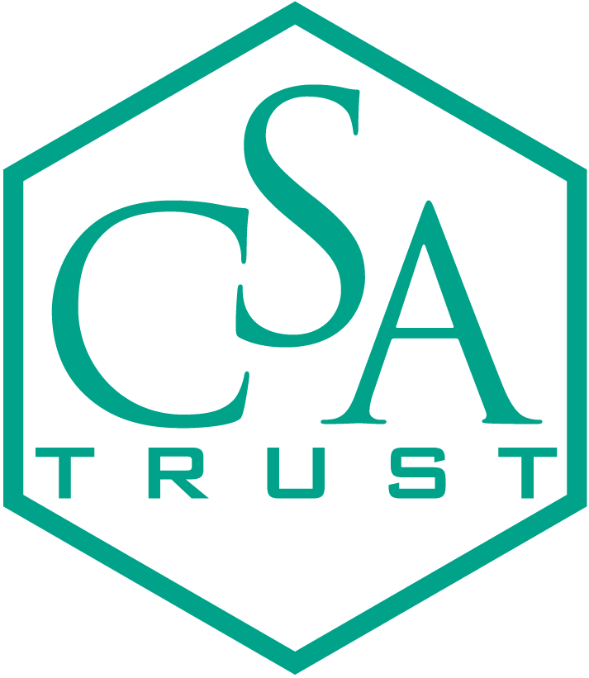 Chemical Structure Association Trust

Applications Invited for CSA Trust Jacques-Émile Dubois Grants for 2013.

The Chemical Structure Association (CSA) Trust is an internationally recognized organization established to promote the critical importance of chemical information to advances in chemical research. In support of its charter, the Trust has created a unique Grant Program, renamed in honor of Professor Jacques-Émile Dubois who made significant contributions to the field of cheminformatics. The Trust is currently inviting the submission of grant applications for 2013.

Purpose of the Grants:
The Grant Program has been created to provide funding for the career development of young researchers who have demonstrated excellence in their education, research or development activities that are related to the systems and methods used to store, process and retrieve information about chemical structures, reactions and compounds. A Grant will be awarded annually up to a maximum of ten thousand U.S. dollars ($10,000). Grants are awarded for specific purposes, and within one year each grantee is required to submit a brief written report detailing how the grant funds were allocated. Grantees are also requested to recognize the support of the Trust in any paper or presentation that is given as a result of that support.

Who is Eligible?
Applicant(s), age 35 or younger, who have demonstrated excellence in their chemical information related research and who are developing careers that have the potential to have a positive impact on the utility of chemical information relevant to chemical structures, reactions and compounds, are invited to submit applications. While the primary focus of the Grant Program is the career development of young researchers, additional bursaries may be made available at the discretion of the Trust. All requests must follow the application procedures noted below and will be weighed against the same criteria.

Which Activities are Eligible?
Grants may be awarded to acquire the experience and education necessary to support research activities; e.g. for travel to collaborate with research groups, to attend a conference relevant to one’s area of research, to gain access to special computational facilities, or to acquire unique research techniques in support of one’s research.

Application Requirements:
Applications must include the following documentation:

- A letter that details the work upon which the Grant application is to be evaluated as well as details on research recently completed by the applicant;
- The amount of Grant funds being requested and the details regarding the purpose for which the Grant will be used (e.g. cost of equipment, travel expenses if the request is for financial support of meeting attendance, etc.). The relevance of the above-stated purpose to the Trust’s objectives and the clarity of this statement are essential in the evaluation of the application);
- A brief biographical sketch, including a statement of academic qualifications;
- Two reference letters in support of the application. Additional materials may be supplied at the discretion of the applicant only if relevant to the application and if such materials provide information not already included in items 1-4. Three copies of the complete application document must be supplied for distribution to the Grants Committee.

Deadline for Applications:
Applications must be received no later than March 14, 2013. Successful applicants will be notified no later than May 2, 2013.

Address for Submission of Applications:
Three copies of the application documentation should be forwarded to: Bonnie Lawlor, CSA Trust Grant Committee Chair, 276 Upper Gulph Road, Radnor, PA 19087, USA. If you wish to enter your application by e-mail, please contact Bonnie Lawlor at blawlor@nfais.org prior to submission so that she can contact you if the e-mail does not arrive.

*******************************
Chemical Structure Association Trust: Recent Jacques-Emile Dubois Grant Awardees

2012

Tu C. Le: CSIRO Division of Materials Science & Engineering, Clayton, VIV, Australia. Tu V. was awarded the Grant for travel to attend a Cheminformatics course at Sheffield University and to visit the Membrane Biophysics group of the Department of Chemistry at imperial College London.

2011

J. B. Brown: Kyoto University, Kyoto, Japan. J.B. was awarded the Grant for travel to work with Professor Ernst Walter-Knappat the Freie University of Berlin and Professor Jean-Phillipe Vert of the Paris MinesTech to continue his work on the development of atomic partial charge kernels

2010

Noel O’Boyle: University College Cork, Ireland. Noel was awarded the grant to both network and present his work on open source software for pharmacophore discovery and searching at the 2010 German Conference on Cheminformatics.

2009

Laura Guasch Pamies: University Rovira & Virgili, Catalonia, Spain. Laura was awarded the Grant to do three months of research at the University of Innsbruck, Austria.

2008

Maciej Haranczyk: University of Gdansk, Poland. Maciej was awarded the Grant to travel to Sheffield University, Sheffield, UK, for a 6-week visit for research purposes.

2007

Rajarshi Guha: Indiana University, Bloomington, IN, USA. Rajarshi was awarded the Grant to attend the Gordon Research Conference on Computer Aided Design in August 2007.

2006

Krisztina Boda: University of Erlangen, Erlangen, Germany. Krisztina was awarded the Grant to attend the 2006 spring National Meeting of the American Chemical Society in Atlanta, GA, USA.

2005

Dr. Val Gillet and Professor Peter Willett: University of Sheffield, Sheffield, UK. They were award the Grant for student travel costs to the 2005 Chemical Structures Conference held in Noordwijkerhout, the Netherlands.

2004

Dr. Sandra Saunders: University of Western Australia, Perth, Australia. Sandra was awarded the Grant to purchase equipment needed for her research.

2003

Prashant S. Kharkar: Institute of Chemical Technology, University of Mumbai, Matunga, Mumbai. Prashant was awarded the Grant to attend the conference, Bioactive Discovery in the New Millennium, in, Lorne, Victoria, Australia (February 2003) to present a paper, The Docking Analysis of 5-Deazapteridine Inhibitors of Mycobacterium avium complex (MAC) Dihydrofolate reductase (DHFR).

2001

Georgios Gkoutos: Imperial College of Science, Technology and Medicine, Dep. of Chemistry. London, UK. Georgios was awarded the Grant to attend the conference, Computational Methods in Toxicology and Pharmacology Integrating Internet Resources, (CMTPI-2001) in Bordeaux, France, to present part of his work on internet-based molecular resource discovery tools.

